Name: Ningyuan Zhang

Section: A

Date: 4/25/2017

Instructor: Akhilesh Tyagi

**Project B Lab Report**

**Tests without Hazard and Forwarding(Part 2 and 3):**

The out put of U:\cpre381\projectB\ASM Files\Pipeline Test\test.asm:

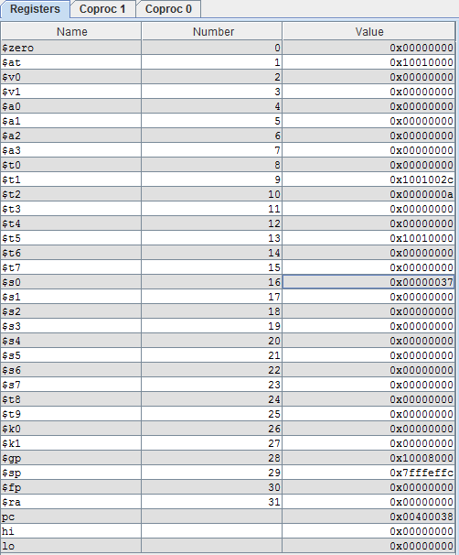

The result of my 5-stage-pipeline without hazard and forwarding:

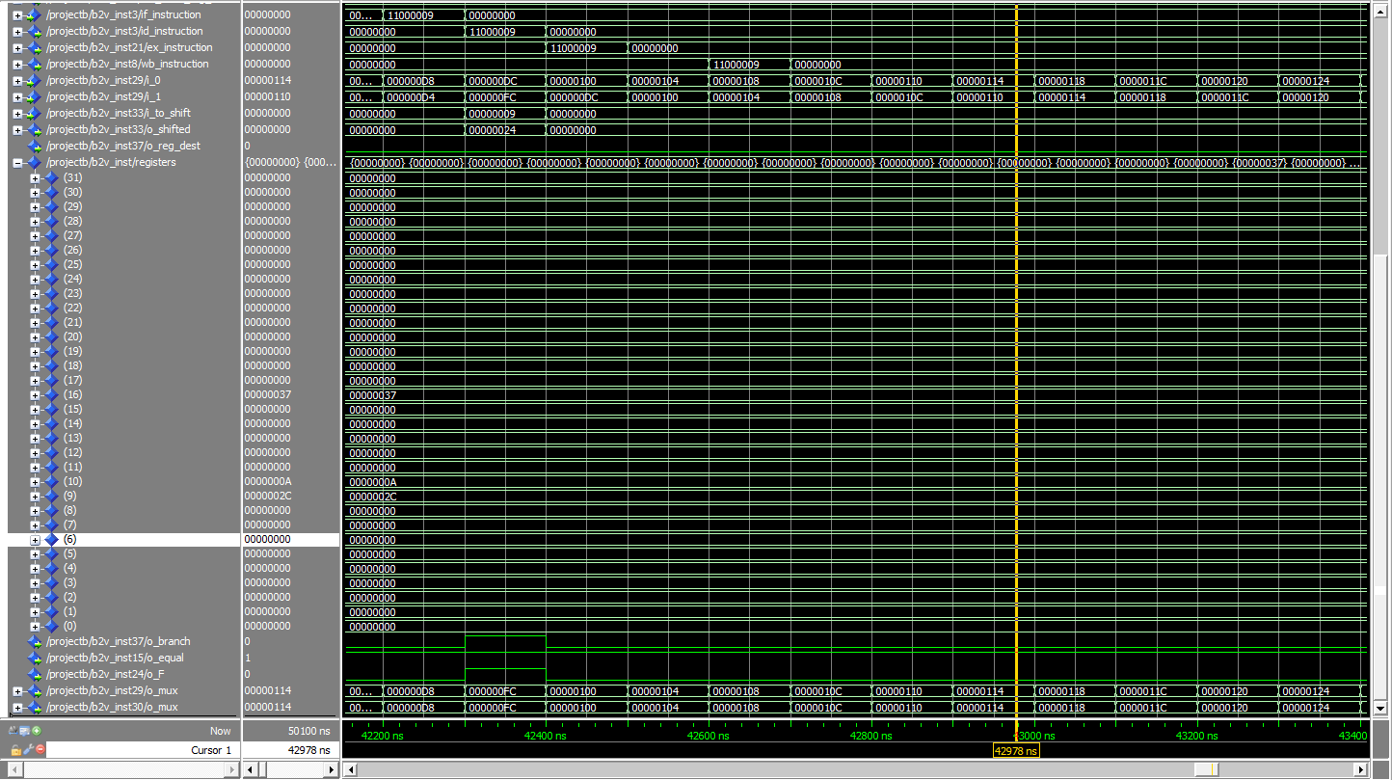

A signal match for different signals:

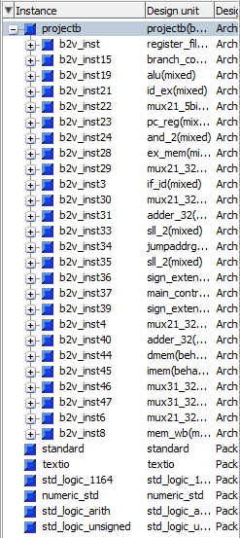

In this part, I originally put the ex_branch into the and gate after comparator, but because the comparators’ signals were from id stage which is 1 cycle quicker than ex stage that sent ex_branch, and this caused that the branch will never achieve, so I switched the ex_branch with id_branch and it worked as it should.

The result of running summation with all correct forwarding and hazard detection:

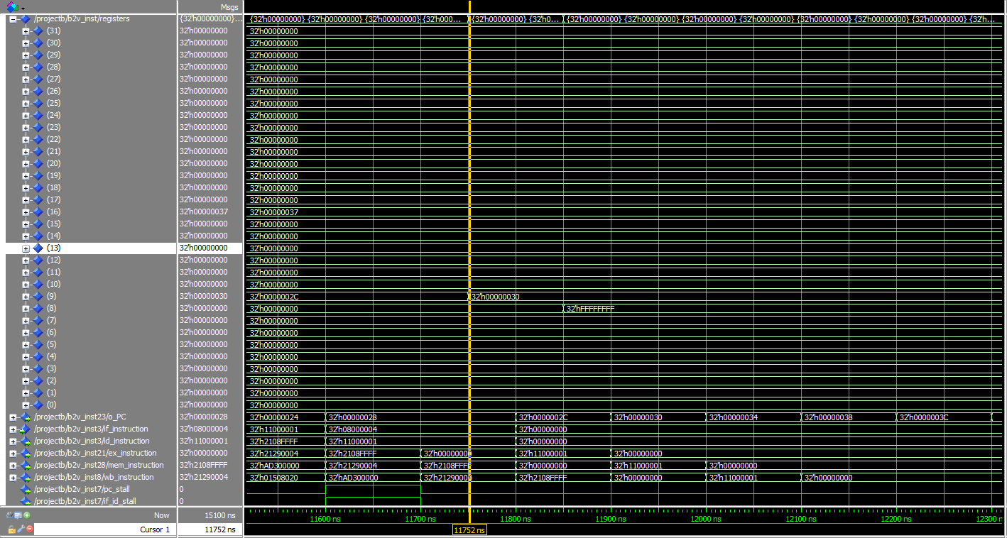

In this part, I actually used the HDandFUtest first to test my forwarding and hazard. with the help of TAs, I corrected all logic mistakes and errors inside the forwarding unit and hazard detection unit.

**The result from HDandFUtest.asm (Part 4 and 5):**

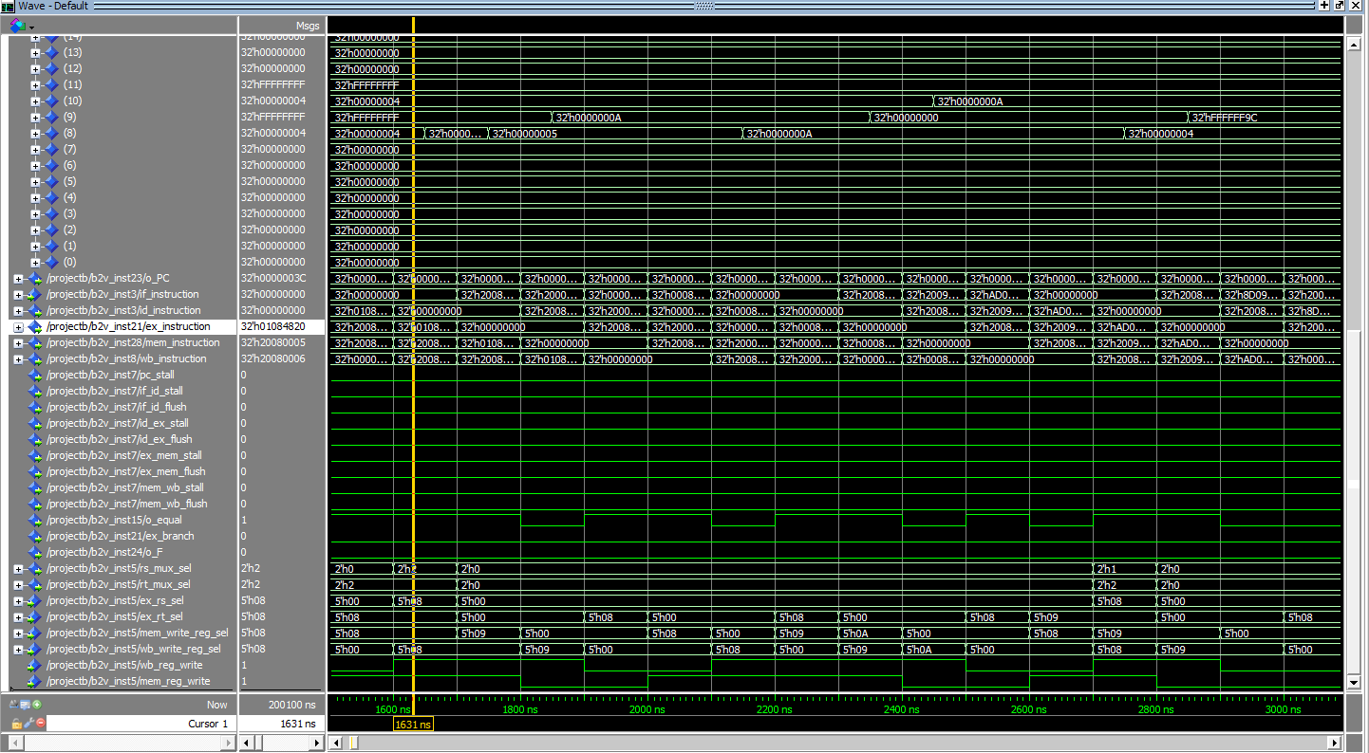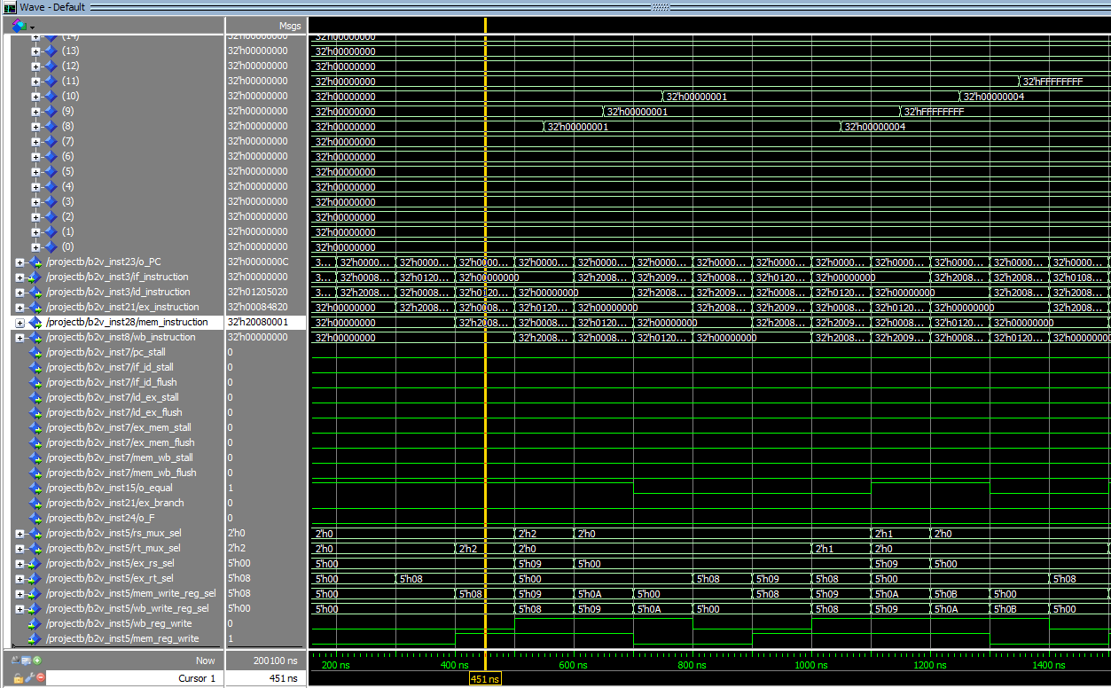

these are the reult of forwarding tests

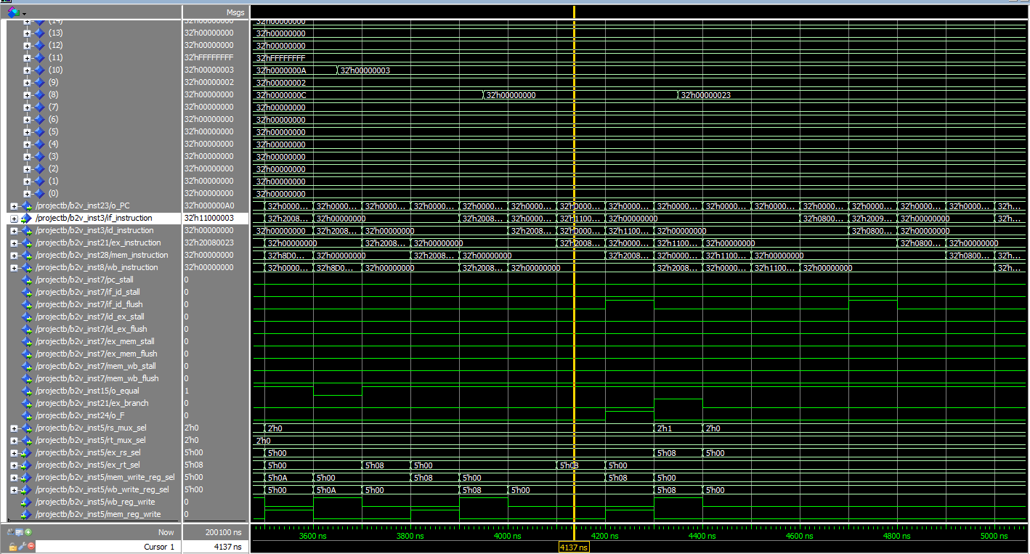

and this is the branch test of forwarding

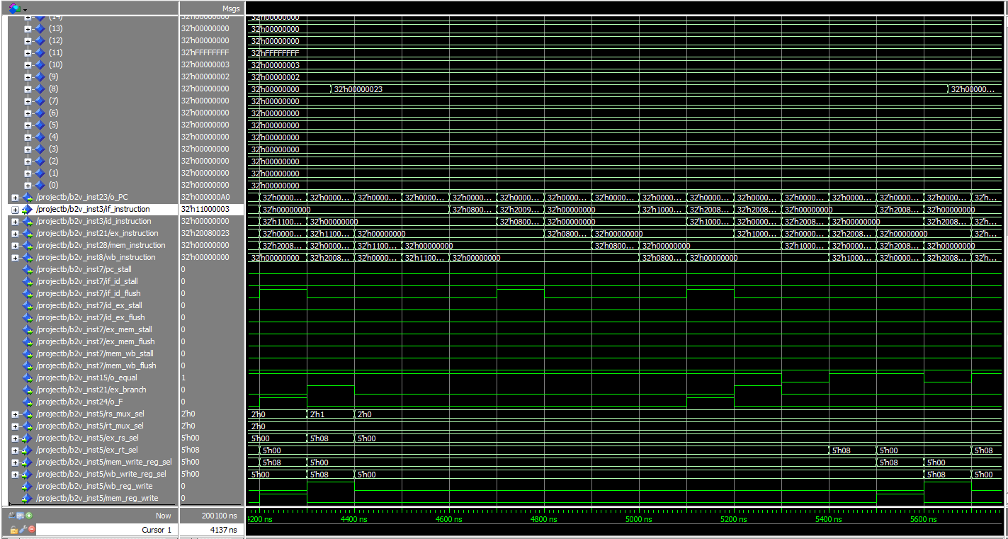

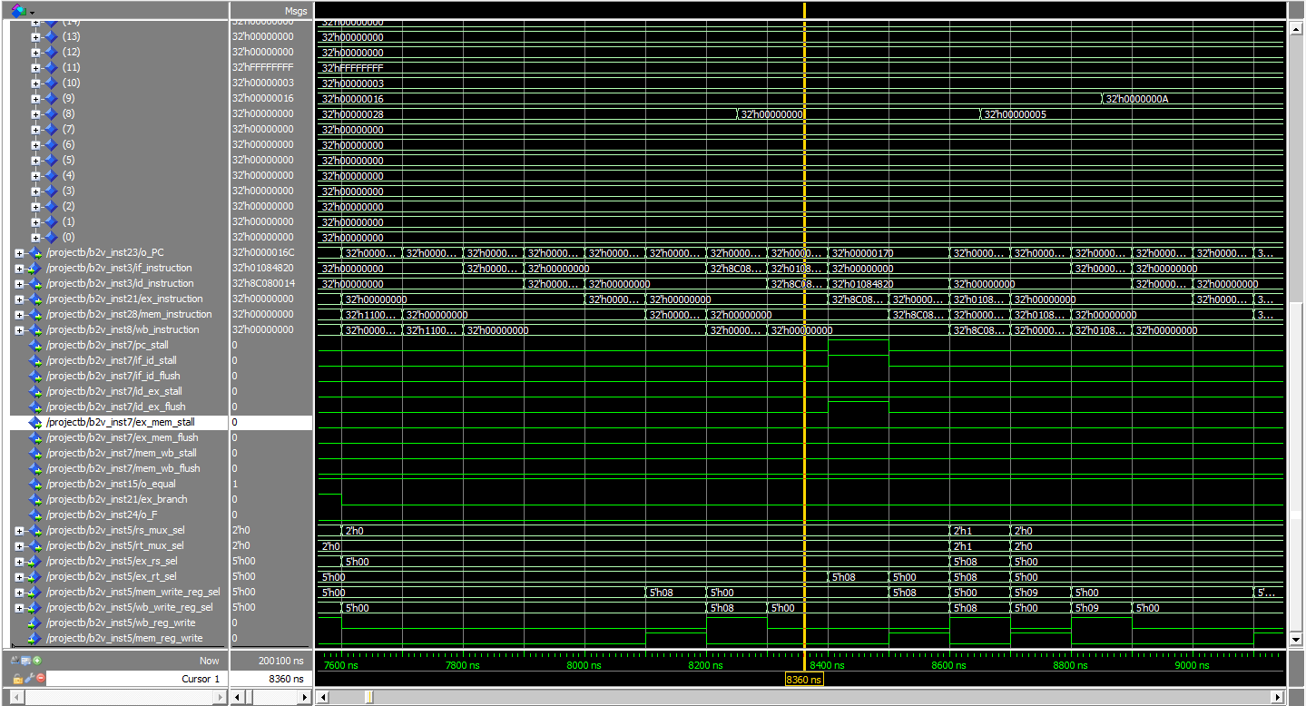

other tests of branch and jump test of hazard

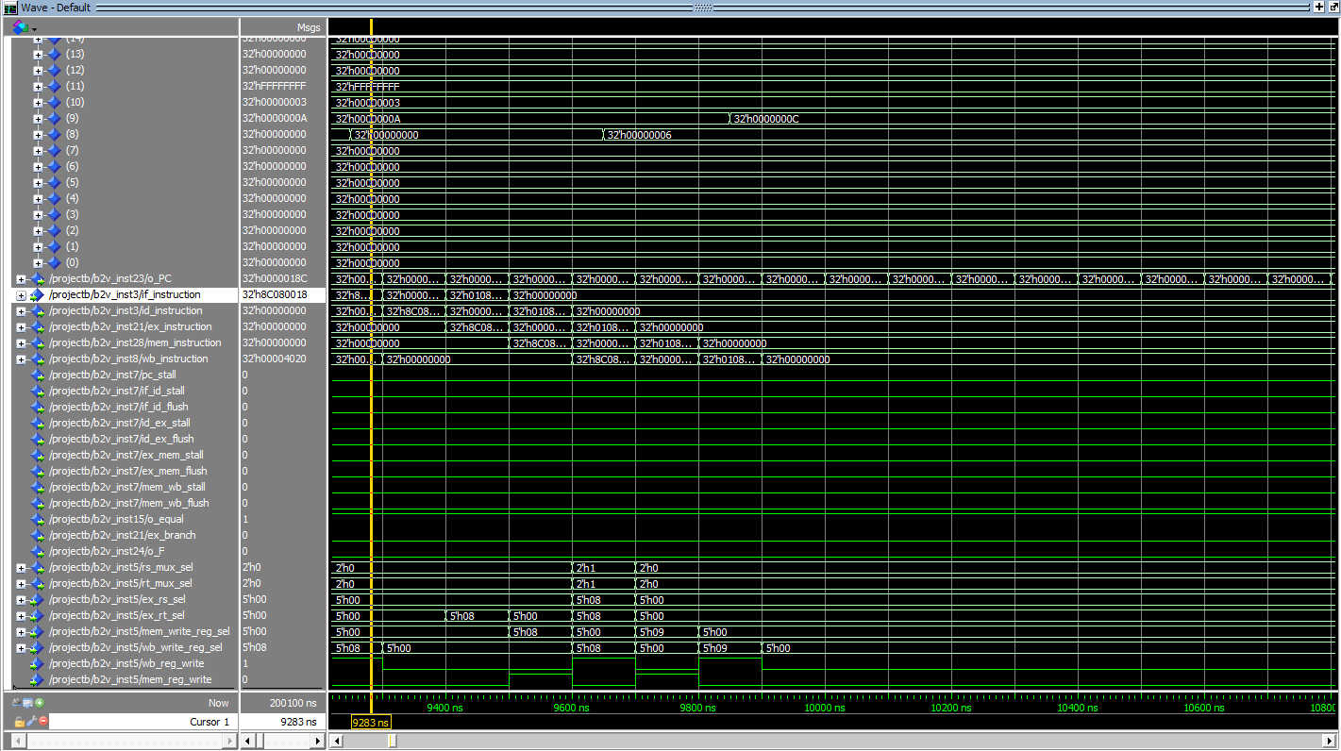

result of HDandFUtest in the end

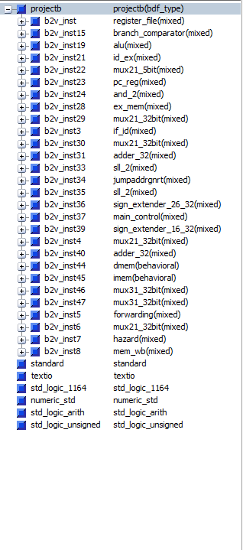

this is the signal matches of waveforms of summation and HDandFUtest asm test files when I do the tests.

**Comments:**

For test convenience, the test wave format was saved as wave.do (for part 2,3), test_wave.do and wave2.do (for test 4,5) under root path. **And every time you need to run any asm test, you have to copy imm.mif of that test to the root path imm.mif!!!**

**Conclusion:**

All files and circuits are included in my zip. This is a really hard project for me, especially with the ideas of stalls and flushes between different pipeline registers. But with several weeks efforts, I finally finished the lab.